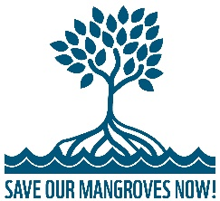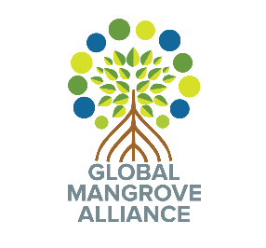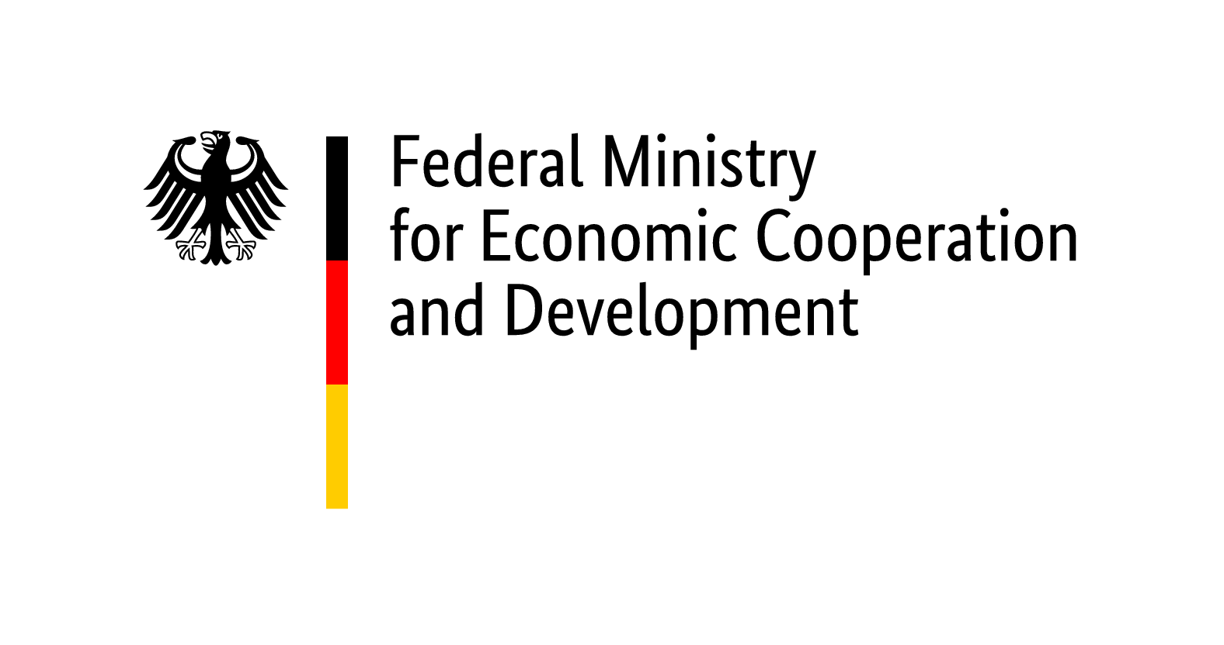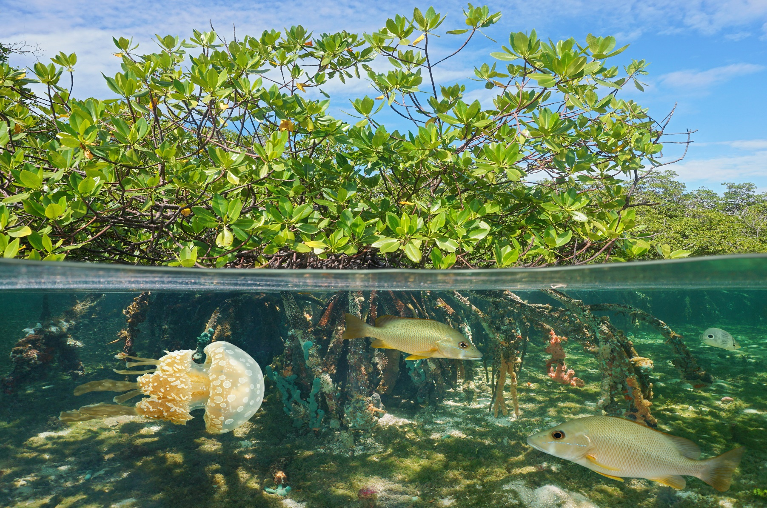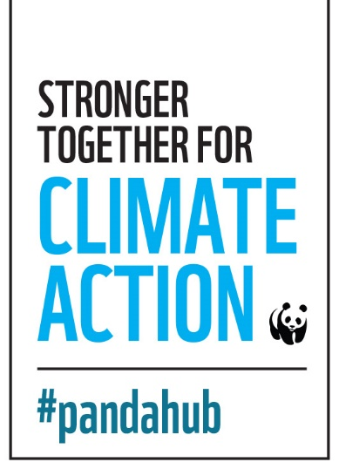

INVITED SPEAKERS AND PANELISTS INCLUDE

* **Stewart Maginnis,** Global Director, Nature-based Solutions Group / Director, Global Forest and Climate Change Programme, IUCN
* **Lisa Schindler Murray**, Policy Advisor, International Climate Change, TNC
* **Susanna Tol,** Senior Communications & Advocacy Officer, Wetlands International
* **Julika Tribukait,** Project Coordinator Mangroves, WWF-Germany
* **Lina Barrera,** Senior Director, International Climate Policy, Conservation International
* **Alex Gamboa**, Manager for Government Initiatives, RARE

Moderated by **Dorothée Herr**, Manager, Oceans & Climate Change, IUCN

The second part of the event will be framed around the Talanoa storytelling principles with stories from Governments such as Australia, Indonesia, and other mangrove countries, about what mangrove ecosystems mean for climate mitigation and adaptation to their country.

This event addresses mangrove and partner countries, multilateral agencies and UN organizations, IGOs and NGOs, as well as mangrove and blue carbon experts and researchers.

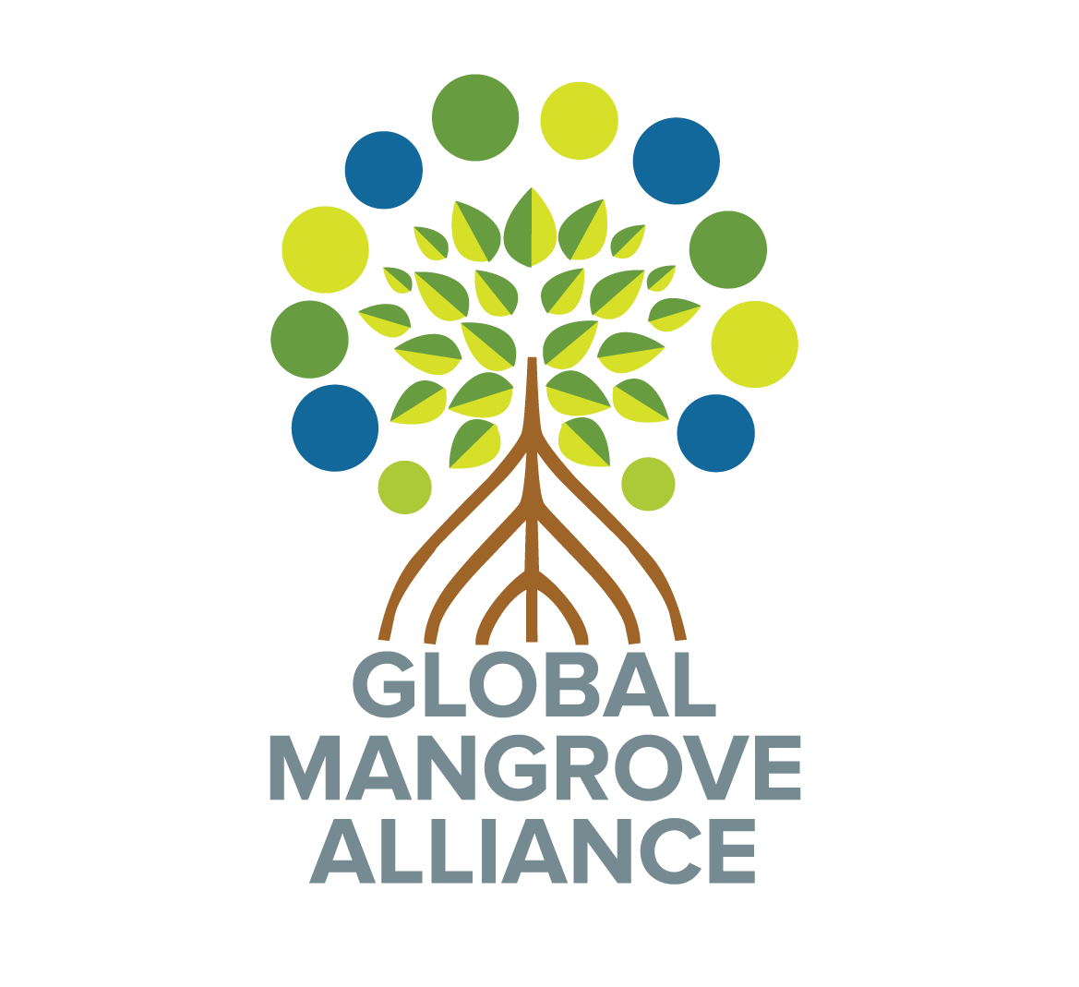

FOR FURTHER INFORMATION CONTACT:

Karen Douthwaite

Lead Specialist, Oceans, WWF-US

+1 202 495 4685

Karen.douthwaite@wwfus.org

OVERVIEW

The recently published IPCC report “Global Warming of 1.5°C” is a reminder of the climate crisis that we are currently facing. Mangroves have remarkable climate change mitigation and adaptation capacities – they store carbon and protect coastal areas. The protection, restoration and sustainable management of mangrove ecosystems are more important than ever – and critical for keeping global temperature increase to 1.5℃.

Join members of the Global Mangrove Alliance, the Save Our Mangroves Now! Initiative, and invited governments as they reflect on the science and economics of natural climate solutions, with an emphasis on mangroves, and how the mitigation potential of nature can help to answer the three questions in the Talanoa Dialogue: Where are we? Where do we want to go? And how do we get there?

DATE TIME

5th December 2018 11:30 – 12:45

VENUE

#Pandahub

WWF Pavilion at COP24

SUPPORTED BY:

The Global Mangrove Alliance and Save Our Mangroves Now!

invite you to attend an important event at COP24 at Katowice, Poland

How do we get there?

The need for a coordinated global mangrove conservation agenda

A SHARED EVENT BY:

©Shutterstock